SGNEC DATA SHEET

MOS INTEGRATED CIRCUIT
S0101,S0102

REMOTE CONTROL TRANSMISSION CMOS IC

DESCRIPTION
The S0101/0102 is an infrared remote control IC based on the μPD612× series of NEC, which is designed and manufactured by SGNEC to meet the needs of domestic market. It provides the same performance and application as NEC’sμPD6121G-001/μPD6122G-001, and can be exchanged withμPD6121G-001/μPD6122G-001. It comes in small package, thus facilitating the design of light and compact remote control transmitters.
The S0101/0102 is using the NEC transmission format that can be widely used in TV, Video recorder, VCD, LD, DVD and other areas. The transmission code consists of leader code, 16-bit customer code and 16-bit data code. By combining external diodes and resistors, a maximum of 65,536 custom codes can be specified.

FEATURES

• Low-voltage operation : V_{DD} = 2.0 to 3.3 V
• Low current dissipation : 1μA Max. ( at standby)
• Custom codes: 65,356 (set by external diodes and resistors)
• Data codes:
• S0101: 32 codes (single input), 3 codes (double input), expandable up to 64 codes through SEL pin
• S0102: 64 codes (single input), 3 codes (double input), expandable up to 128 codes through SEL pin
• Pin compatibility:
• S0101 is pin-compatible with the μPD6121G-001
• S0102 is pin-compatible with the μPD6122G-001

ORDERING INFORMATION
Part number Package
S0101 20-pin plastic SOP (375 mil)
S0102 24-pin plastic SOP (375 mil)

PIN CONFIGURATION (Top View)
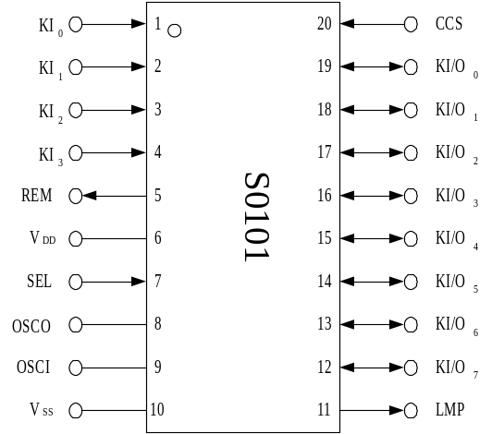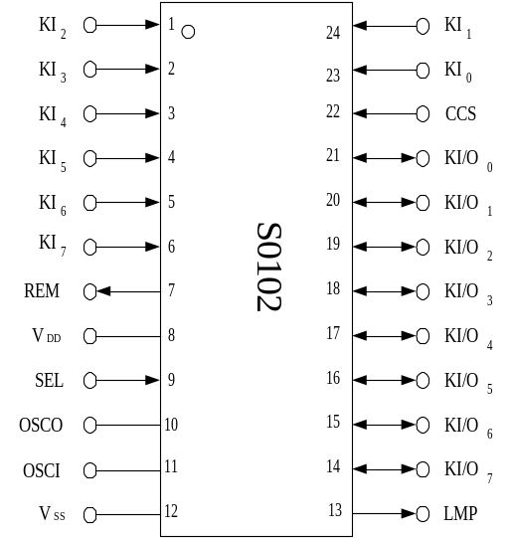• S0101 • S0102

PIN IDENTIFICATIONS
CCS : Custom code selection input REM : Remote output
KI₀ - KI₇ : Key input SEL : SEL input
KI/O₀ - KI/O₇ : Key input/output VDD : Power supply pin
LMP : Lamp output VSS : GND pin
OSCI, OSCO : Resonator connection pin

BLOCK DIAGRAM

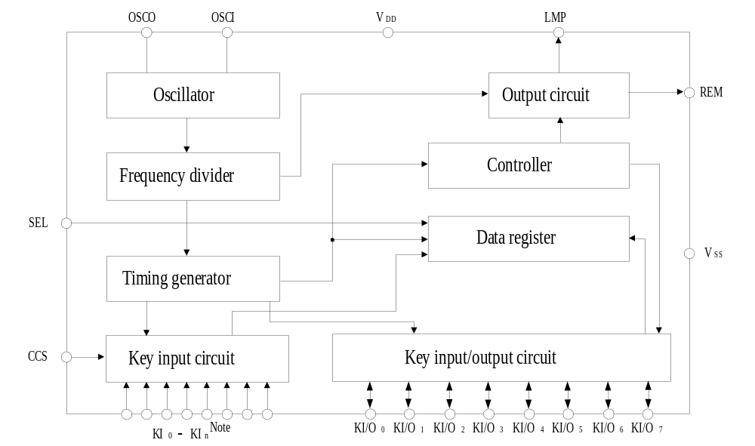Note S0101: KI₀-KI₃
S0102: KI₀-KI₇

DIFFERENCES BETWEEN PRODUCTS

_{Item} ^{Part number} | S0101 | S0102
Operating voltage | V_{DD} = 2.0 to 3.0 V
Current consumption  (at standby) | 1μA Max.
Custom codes | 65,536(16-bit setting)
Data codes | 32×2 | 64×2
No. of KI pins | 4 | 8
No. of KI/O pins | 8
SEL pin | Provided
Transmission format | NEC transmission format
Package | 20-pin plastic SOP (375 mil) | 24-pin plastic SOP (375 mil)

- PIN FUNCTIONS

(1) Key Input pins (KI₀ to KI₇), key input/output pins (KI/O₀ to KI/O₇)
A pull-down resistor is placed between key input pins and a V_{SS} pin. When several keys are pressed simultaneously, the transmission of the corresponding signals is inhibited by a multiple-input prevention circuit. In the case of double-key input, transmission is inhibited if both keys are pressed simultaneously (within 36 ms interval); if not pressed simultaneously, the priority of transmission is first key, then second key.
When a key is pressed, the custom code and data code reading is initiated, and 36ms later, output to REM output is initiated. Thus if the key is pressed during the initial 36ms, one transmission is performed. If a key is kept pressed for 108 ms or longer, only leader codes are consecutively transmitted until the key is released.
Keys can be operated intermittently at intervals as short as 126 ms (interval between two on's), making this an extremely fast-response system.

(2) Resonator connection pins (OSCI, OSCO)
The oscillator starts operating when it receives a key input. Use a ceramic resonator with a frequency between 400 and 500 kHz.

(3) Power-supply pin
The power supply voltage is supplied by two 3-V batteries. A board range of operating power supply voltage is allowed, from 2.0 to 3.3V. The supply current falls below 1μA when the oscillator is inactive when no keys are pressed.

(4) REM output pin
The REM output pin outputs the transmission code, which consists of the leader code, custom code (16 bits), and data code (16 bits) (Refer to 2.NEC TRANSMISSION FORMAT (REM OUTPUT)).

(5) SEL input pin
By controlling D₇ of the data code with this pin, the S0101 and S0102 can transmit 64 and 128 different data codes, respectively. By connecting the SEL pin to V_{DD} or V_{SS}, D₇ is set to "0" or "1", respectively.
This pin has high-impedance input, therefore be sure to connect it either to V_{DD} or V_{SS}.

(6) CCS input pin
By placing a diode between the CCS pin and the KI/O pin, it its possible to set a custom code. When a diode is connected, the corresponding custom code is "1", and when not connected, it is "0".

(7) LMP output pin
The LMP pin outputs a low-level signal while the REM pin outputs a transmission code.

2. NEC TRANSMISSION FORMAT (REM OUTPUT)
The NEC transmission format consists of the transmission of a leader code, 16-bit custom codes (Custom Code, Custom Code’), and 16-bit data codes (Data Code, Data Code) at one time, as shown in Figure 2-1.
Also refer to 4.REMOTE OUPUT WAVEFORM.
Data Code is the inverted code of Data code.
The leader code consists of a 9-ms carrier waveform and a 4.5-ms OFF waveform and is used as leader for the ensuing code to facilitate reception detection.
Codes use the PPM (Pulse Position Modulation) method, and the signals "1" and "0" are fixed bye the interval between pulses.

Figure 2-1. REM Output Code
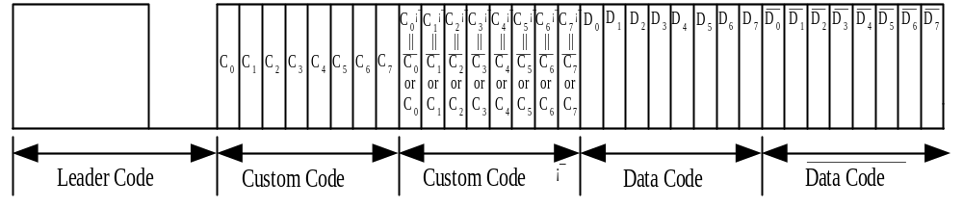

Cautions 1. Use any of the possible 256 kinds of custom codes specified with 00xxH
(diode not connected), as desired.
2. When receiving data in the NEC transmission format, check that the 32 bits made up of the 16-bit custom code (Custom Code, Custom Code’) and the 16-bit data code (Data Code, Data Code) are fully decoded, and that there are no signals with the 33rd bit and after (be sure to check also Data Code).

3. CUSTOM CODE (CUSTOM CODE, CUSTOM CODE’) SETTING
Figure 3-1. Custom Code Setting

Higher 8 bits of custom code | Lower 8 bits of custom code’
Fixed by external diode bit | Fixed by external pull-up resistor bit

A custom code setting example is shown below.

Each of the higher 8 bits of the custom code is set to "1" when a diode is connected between the CCS pin and the corresponding KI/O pin, and is set to "0" when no diode is connected. If a pull-up resistor is connected to the KI/O pin corresponding to one of the lower 8bits of the custom code’, the bit is first set to "1". Based on the 1’s information of the lower 8 bits of the custom code’, the corresponding bit of the higher 8 bits of the custom code is the captured and not inverted. The non-inverted value is finally overwritten to the corresponding bit of the lower 8 bits of the custom code’. The inverse occurs when no pull-up resistor is connected.
It follows from the above that the custom code can be set in 65,536 different ways depending on whether or not a diode and/or pull-up resistor are present.
Please refer to Figure 3-2 Example of Custom Code Setting

Figure 3-2 Example of Custom Code Setting

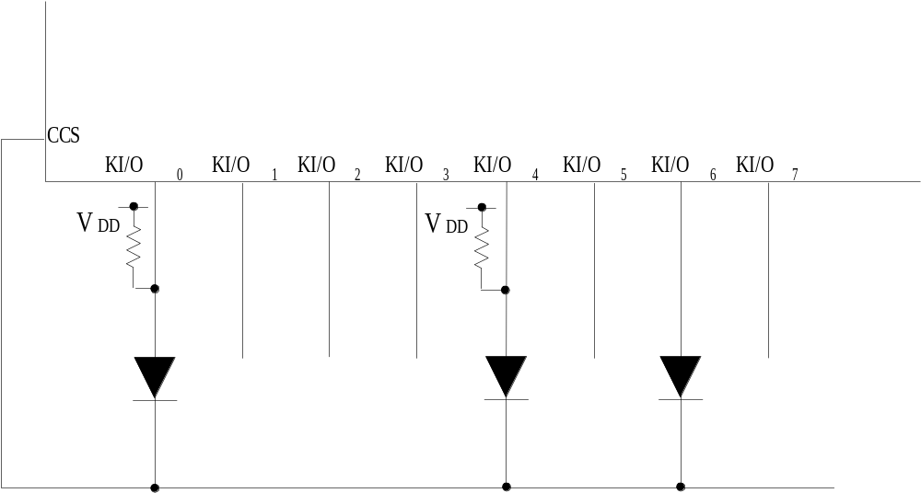Configuration example

The higher 8 bits of the custom code are determined by the diode connected to the CCS pin and KI/O pin.
Set custom code Higher 8 bits of custom code

1 0 0 0 1 0 1 0

C₀ C₁ C₂ C₃ C₄ C₅ C₆ C₇

Set to "1" by diode

The inversion/non-inversion of the lower 8 bits of the custom code’ is determined by the
pull-up resistor connected to the KI/O pin.
Set custom code Lower 8 bits of custom code’

1 0 0 0 1 0 0 0

C₀’ C₁’ C₂’ C₃’ C₄’ C₅’ C₆’ C₇’

Set to "1" by pull-up resistor,
that is, bit for non-inversion of custom code is set
1:Non-inversion for C₀ toC₇
0:inversion for C₀ toC₇

When the above-described setting is done, the following custom code is output.
Custom code

Higher 8 bits of custom code Lower 8 bits of custom code’
1 0 0 0 1 0 1 0
1 1 1 1 1 1 0 1

C₀ C₁ C₂ C₃ C₄ C₅ C₆ C₇ C₀’ C₁’ C₂’ C₃’ C₄’ C₅’ C₆’ C₇’
C₀ C₁ C₂ C₃ C₄ C₅ C₆ C₇

Remark Codes are transmitted from the LSB.

4. REMOTE OUTPUT WAVEFORM (NEC TRANSMISSION FORMAT:
ONE-SHOT COMMAND TRANSMISSION MODE)
• when fosc = 455 kHz
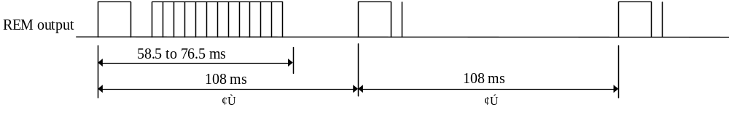(1) Remote (REM) output (from stage②, transmission occurs only when key is kept depressed)
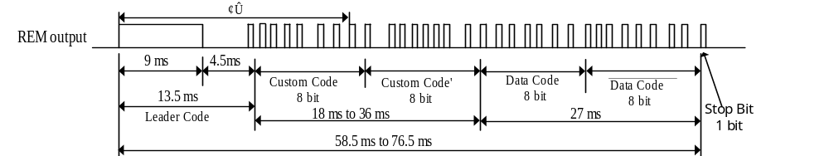(2) Magnification of stage ①
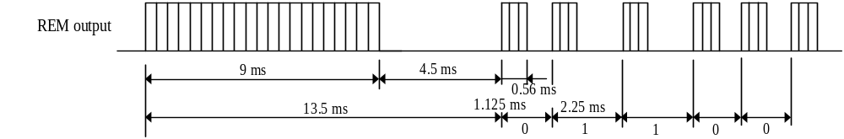(3) Magnification of waveform ③
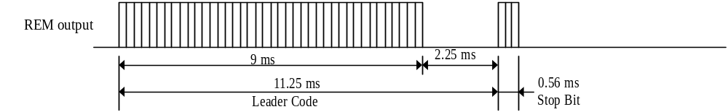(4) Magnification of waveform ②
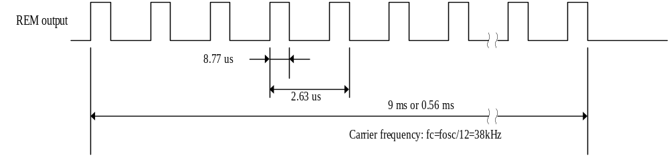(5) Carrier waveform (Magnification of HIGH period of codes)

Remark If a key is kept depressed, the second and subsequent times, only the leader code and the stop bit are transmitted, which allows power savings for the infrared-emitting diode.

- KEY DATA CODES ( SINGLE INPUT )
KEY | CONNECTION |  |  |  |  | DATA CODE
KEY | KI₀ | KI₁ | KI₂ | KI₃ | KI/O | D₀ |  | D₁ |  | D₂ |  | D₃ |  | D₄ |  | D₅ |  | D₆ |  | D₇^{Note}
K1 | * |  |  |  | KI/O₀ | 0 |  | 0 |  | 0 |  | 0 |  | 0 |  | 0 |  | 0 |  | 0/1
K2 |  | * |  |  | KI/O₀ | 1 |  | 0 |  | 0 |  | 0 |  | 0 |  | 0 |  | 0 |  | 0/1
K3 |  |  | * |  | KI/O₀ | 0 |  | 1 |  | 0 |  | 0 |  | 0 |  | 0 |  | 0 |  | 0/1
K4 |  |  |  | * | KI/O₀ | 1 |  | 1 |  | 0 |  | 0 |  | 0 |  | 0 |  | 0 |  | 0/1
K5 | * |  |  |  | KI/O₁ | 0 |  | 0 |  | 1 |  | 0 |  | 0 |  | 0 |  | 0 |  | 0/1
K6 |  | * |  |  | KI/O₁ | 1 |  | 0 |  | 1 |  | 0 |  | 0 |  | 0 |  | 0 |  | 0/1
K7 |  |  | * |  | KI/O₁ | 0 |  | 1 |  | 1 |  | 0 |  | 0 |  | 0 |  | 0 |  | 0/1
K8 |  |  |  | * | KI/O₁ | 1 |  | 1 |  | 1 |  | 0 |  | 0 |  | 0 |  | 0 |  | 0/1
K9 | * |  |  |  | KI/O₂ | 0 |  | 0 |  | 0 |  | 1 |  | 0 |  | 0 |  | 0 |  | 0/1
K10 |  | * |  |  | KI/O₂ | 1 |  | 0 |  | 0 |  | 1 |  | 0 |  | 0 |  | 0 |  | 0/1
K11 |  |  | * |  | KI/O₂ | 0 |  | 1 |  | 0 |  | 1 |  | 0 |  | 0 |  | 0 |  | 0/1
K12 |  |  |  | * | KI/O₂ | 1 |  | 1 |  | 0 |  | 1 |  | 0 |  | 0 |  | 0 |  | 0/1
K13 | * |  |  |  | KI/O₃ | 0 |  | 0 |  | 1 |  | 1 |  | 0 |  | 0 |  | 0 |  | 0/1
K14 |  | * |  |  | KI/O₃ | 1 |  | 0 |  | 1 |  | 1 |  | 0 |  | 0 |  | 0 |  | 0/1
K15  • S0101  • S0102 |  |  | * |  | KI/O₃ | 0 |  | 1 |  | 1 |  | 1 |  | 0 |  | 0 |  | 0 |  | 0/1
K16 |  |  |  | * | KI/O₃ | 1 |  | 1 |  | 1 |  | 1 |  | 0 |  | 0 |  | 0 |  | 0/1
K17 | * |  |  |  | KI/O₄ | 0 |  | 0 |  | 0 |  | 0 |  | 1 |  | 0 |  | 0 |  | 0/1
K18 |  | * |  |  | KI/O₄ | 1 |  | 0 |  | 0 |  | 0 |  | 1 |  | 0 |  | 0 |  | 0/1
K19 |  |  | * |  | KI/O₄ | 0 |  | 1 |  | 0 |  | 0 |  | 1 |  | 0 |  | 0 |  | 0/1
K20 |  |  |  | * | KI/O₄ | 1 |  | 1 |  | 0 |  | 0 |  | 1 |  | 0 |  | 0 |  | 0/1
K21 | * |  |  |  | KI/O₅ | 0 |  | 0 |  | 1 |  | 0 |  | 1 |  | 0 |  | 0 |  | 0/1
K22 |  | * |  |  | KI/O₅ | 1 |  | 0 |  | 1 |  | 0 |  | 1 |  | 0 |  | 0 |  | 0/1
K23 |  |  | * |  | KI/O₅ | 0 |  | 1 |  | 1 |  | 0 |  | 1 |  | 0 |  | 0 |  | 0/1
K24 |  |  |  | * | KI/O₅ | 1 |  | 1 |  | 1 |  | 0 |  | 1 |  | 0 |  | 0 |  | 0/1
K25 | * |  |  |  | KI/O₆ | 0 |  | 0 |  | 0 |  | 1 |  | 1 |  | 0 |  | 0 |  | 0/1
K26 |  | * |  |  | KI/O₆ | 1 |  | 0 |  | 0 |  | 1 |  | 1 |  | 0 |  | 0 |  | 0/1
K27 |  |  | * |  | KI/O₆ | 0 |  | 1 |  | 0 |  | 1 |  | 1 |  | 0 |  | 0 |  | 0/1
K28 |  |  |  | * | KI/O₆ | 1 |  | 1 |  | 0 |  | 1 |  | 1 |  | 0 |  | 0 |  | 0/1
K29 | * |  |  |  | KI/O₇ | 0 |  | 0 |  | 1 |  | 1 |  | 1 |  | 0 |  | 0 |  | 0/1
K30 |  | * |  |  | KI/O₇ | 1 |  | 0 |  | 1 |  | 1 |  | 1 |  | 0 |  | 0 |  | 0/1
K31 |  |  | * |  | KI/O₇ | 0 |  | 1 |  | 1 |  | 1 |  | 1 |  | 0 |  | 0 |  | 0/1
K32 |  |  |  | * | KI/O₇ | 1 |  | 1 |  | 1 |  | 1 |  | 1 |  | 0 |  | 0 |  | 0/1
KEY | CONNECTION |  |  |  |  | DATA CODE
KEY | KI₄ | KI₅ | KI₆ | KI₇ | KI/O | D₀ | D₁ |  | D₂ |  | D₃ |  | D₄ |  | D₅ |  | D₆ |  | D₇
K33 | * |  |  |  | KI/O₀ | 0 | 0 |  | 0 |  | 0 |  | 0 |  | 0 |  | 1 |  | 0/1
K34 |  | * |  |  | KI/O₀ | 1 | 0 |  | 0 |  | 0 |  | 0 |  | 0 |  | 1 |  | 0/1
K35 |  |  | * |  | KI/O₀ | 0 | 1 |  | 0 |  | 0 |  | 0 |  | 0 |  | 1 |  | 0/1
K36 |  |  |  | * | KI/O₀ | 1 | 1 |  | 0 |  | 0 |  | 0 |  | 0 |  | 1 |  | 0/1
K37 | * |  |  |  | KI/O₁ | 0 | 0 |  | 1 |  | 0 |  | 0 |  | 0 |  | 1 |  | 0/1
K38 |  | * |  |  | KI/O₁ | 1 | 0 |  | 1 |  | 0 |  | 0 |  | 0 |  | 1 |  | 0/1
K39 |  |  | * |  | KI/O₁ | 0 | 1 |  | 1 |  | 0 |  | 0 |  | 0 |  | 1 |  | 0/1
K40 |  |  |  | * | KI/O₁ | 1 | 1 |  | 1 |  | 0 |  | 0 |  | 0 |  | 1 |  | 0/1
K41 | * |  |  |  | KI/O₂ | 0 | 0 |  | 0 |  | 1 |  | 0 |  | 0 |  | 1 |  | 0/1
K42 |  | * |  |  | KI/O₂ | 1 | 0 |  | 0 |  | 1 |  | 0 |  | 0 |  | 1 |  | 0/1
K43 |  |  | * |  | KI/O₂ | 0 | 1 |  | 0 |  | 1 |  | 0 |  | 0 |  | 1 |  | 0/1
K44 |  |  |  | * | KI/O₂ | 1 | 1 |  | 0 |  | 1 |  | 0 |  | 0 |  | 1 |  | 0/1
K45 | * |  |  |  | KI/O₃ | 0 | 0 |  | 1 |  | 1 |  | 0 |  | 0 |  | 1 |  | 0/1
K46  • S0102  only |  | * |  |  | KI/O₃ | 1 | 0 |  | 1 |  | 1 |  | 0 |  | 0 |  | 1 |  | 0/1
K47 |  |  | * |  | KI/O₃ | 0 | 1 |  | 1 |  | 1 |  | 0 |  | 0 |  | 1 |  | 0/1
K48 |  |  |  | * | KI/O₃ | 1 | 1 |  | 1 |  | 1 |  | 0 |  | 0 |  | 1 |  | 0/1
K49 | * |  |  |  | KI/O₄ | 0 | 0 |  | 0 |  | 0 |  | 1 |  | 0 |  | 1 |  | 0/1
K50 |  | * |  |  | KI/O₄ | 1 | 0 |  | 0 |  | 0 |  | 1 |  | 0 |  | 1 |  | 0/1
K51 |  |  | * |  | KI/O₄ | 0 | 1 |  | 0 |  | 0 |  | 1 |  | 0 |  | 1 |  | 0/1
K52 |  |  |  | * | KI/O₄ | 1 | 1 |  | 0 |  | 0 |  | 1 |  | 0 |  | 1 |  | 0/1
K53 | * |  |  |  | KI/O₅ | 0 | 0 |  | 1 |  | 0 |  | 1 |  | 0 |  | 1 |  | 0/1
K54 |  | * |  |  | KI/O₅ | 1 | 0 |  | 1 |  | 0 |  | 1 |  | 0 |  | 1 |  | 0/1
K55 |  |  | * |  | KI/O₅ | 0 | 1 |  | 1 |  | 0 |  | 1 |  | 0 |  | 1 |  | 0/1
K56 |  |  |  | * | KI/O₅ | 1 | 1 |  | 1 |  | 0 |  | 1 |  | 0 |  | 1 |  | 0/1
K57 | * |  |  |  | KI/O₆ | 0 | 0 |  | 0 |  | 1 |  | 1 |  | 0 |  | 1 |  | 0/1
K58 |  | * |  |  | KI/O₆ | 1 | 0 |  | 0 |  | 1 |  | 1 |  | 0 |  | 1 |  | 0/1
K59 |  |  | * |  | KI/O₆ | 0 | 1 |  | 0 |  | 1 |  | 1 |  | 0 |  | 1 |  | 0/1
K60 |  |  |  | * | KI/O₆ | 1 | 1 |  | 0 |  | 1 |  | 1 |  | 0 |  | 1 |  | 0/1
K61 | * |  |  |  | KI/O₇ | 0 | 0 |  | 1 |  | 1 |  | 1 |  | 0 |  | 1 |  | 0/1
K62 |  | * |  |  | KI/O₇ | 1 | 0 |  | 1 |  | 1 |  | 1 |  | 0 |  | 1 |  | 0/1
K63 |  |  | * |  | KI/O₇ | 0 | 1 |  | 1 |  | 1 |  | 1 |  | 0 |  | 1 |  | 0/1
K64 |  |  |  | * | KI/O₇ | 1 | 1 |  | 1 |  | 1 |  | 1 |  | 0 |  | 1 |  | 0/1

Note Bit D7 is “0” when the SEL pin is connected to VDD, and “1” when it is connected to VSS.

6. DOUBLE-INPUT OPERATION
All keys are provided with a multiple-input prevention circuit. When two or more keys are pressed simultaneously, no signal is transmitted; but when the keys K21 and K22, K21 and K23, or K21 and K24 are pressed together, D₅ is set to "1". However, the way keys are pressed determines the priority: If K22/K23/K24 are pressed 126 ms or longer after K21 is pressed , transmission is performed in this mode.
Double-input key operation is ideally suited for tape recording error prevention applications.

Double-Input Operation Key Codes
KEY | D₀ | D₁ | D₂ | D₃ | D₄ | D₅ | D₆ | D₇
K21 + K22 | 1 | 0 | 1 | 0 | 1 | 1 | 0 | 0/1
K21 + K23 | 0 | 1 | 1 | 0 | 1 | 1 | 0 | 0/1
K21 + K24 | 1 | 1 | 1 | 0 | 1 | 1 | 0 | 0/1

Double-Input Operation Timing
- Double-input transmission
K21
K21 code transmission D5+ K22/K23/K24 code transmission
t > 126 ms
push
K22/K23/K24

push
② No operation
K21
K21 code transmission Transmission stop
push 36 ms < t < 126 ms
K22/K23/K24

push
③ No operation
K21
No transmission
push -36 ms < t < 36 ms
K22/K23/K24

push
④ No operation
K21

t > 126 ms push
K22/K23/K24
K22/K23/K24 code transmission Transmission stop
push

7. APPLICATION CIRCUIT EXAMPLE
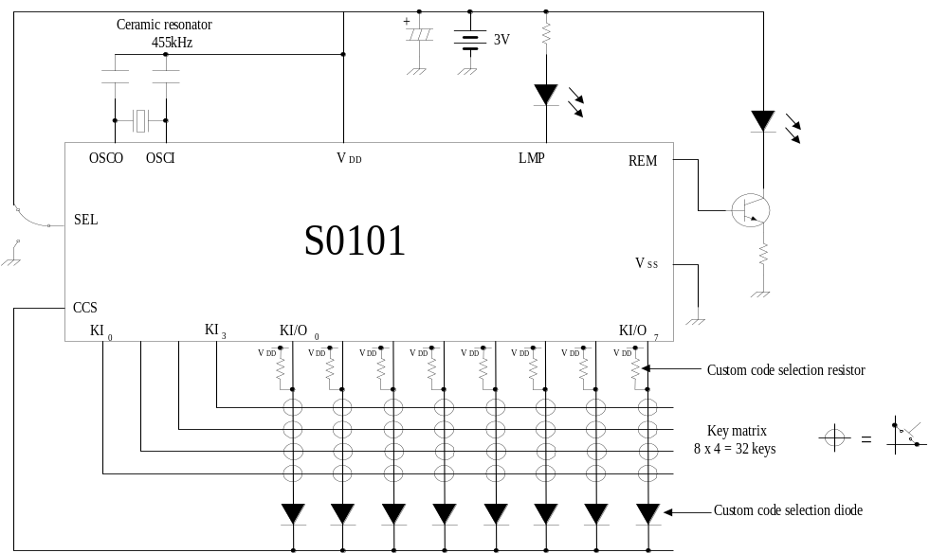(1) Example application circuit using S0101

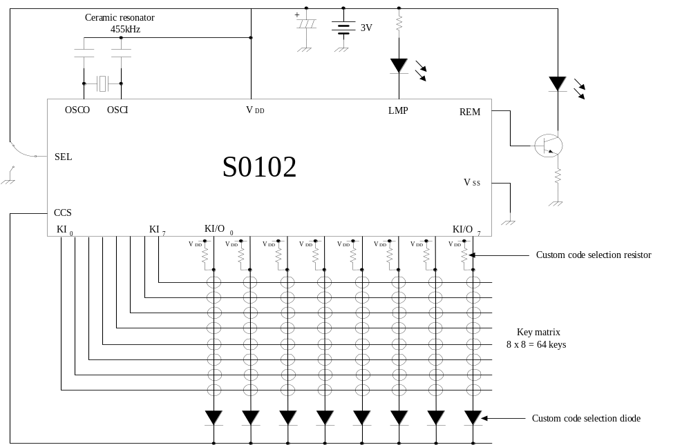(2) Example application circuit using S0102
8. ELECTRICAL SPECIFICATIONS

Absolute Maximum Ratings (TA = 25 ℃)
Parameter | Symbol | Ratings | Unit
Supply voltage | VDD | -0.3 to +6.0 | V
Input voltage | VI | -0.3 to VDD + 0.3 | V
Power dissipation | PD | 250 | mW
Operating ambient temperature | TA | -20 to +75 | ℃
Storage temperature | Tstg | -40 to +125 | ℃

Recommended Operating Conditions (TA = -20 to +75 ℃)
Parameter | Symbol | MIN. | TYP. | MAX. | Unit
Supply voltage | VDD | 2.0 | 3.0 | 3.3 | V
Oscillation frequency | fosc | 400 | 455 | 500 | kHz
Input voltage | VI | 0 |  | VDD | V
Custom code select pull-up resistor | RUP | 160 | 200 | 240 | kΩ

DC Characteristics (TA = 25 ℃, VDD = 3.0 v)
Parameter | Symbol | Condition | MIN. | TYP. | MAX. | Unit
Supply current 1 | IDD1 | fosc = 455 kHz |  | 0.1 | 1 | mA
Supply current 2 | IDD21 | fosc = STOP |  |  | 1 | μA
REM output current High | IOH1 | VO = 1.5 V | -5 | -8 |  | mA
REM output current Low | IOL1 | VO = 0.3 V | 15 | 30 |  | μA
LMP output current High | IOH2 | VO = 2.7 V | -15 | -30 |  | μA
LMP output current Low | IOL2 | VO = 0.3 V | 1 | 1.5 |  | mA
KI input current High | IIH1 | VI = 3.0 V | 10 |  | 30 | μA
KI input current Low | IIL1 | VI = 0 V |  |  | -2.0 | μA
KI, SEL input voltage High | VIH1 |  | 2.1 |  | 3.0 | V
KI, SEL input voltage Low | VIL1 |  | 0 |  | 0.7 | V
KI/O input voltage High | VIH2 |  | 1.3 |  |  | V
KI/O input voltage Low | VIL2 |  |  |  | 0.4 | V
KI/O input current High | IIH2 | VI = 3.0 V | 2 |  | 7 | μA
KI/O input current Low | IIL2 | VI = 0 V |  |  | -2.0 | μA
KI/O output current High | IOH3 | VO = 2.5 V | -1.0 |  | -2.5 | mA
KI/O output current Low | IOL3 | VO = 1.7 V | 35 |  | 100 | μA
CCS input voltage High | VIH3 |  | 1.1 |  |  | V
CCS input current High | IIH3 | Pull-up, VI = 3.0 V |  |  | 2.0 | μA
CCS input current Low | IIL3 | Pull-up, VI = 0 V | -3 |  | -8 | μA
CCS input current High | IIH4 | Pull-down, VI = 3.0 V | 10 |  | 30 | μA
CCS input current Low | IIL4 | Pull-down, VI = 0 V |  |  | -2.0 | μA

Recommended Ceramic Resonators (TA = -20 to +75 ℃, , VDD = 2.0 to 3.0 v)

• S0101, 0102
 | Recommended constant [pF] |  | Operating voltage [V]
 | C1 | C2 | MIN. | MAX.
455kHz OSC | 220 | 220 | 2.0 | 3.3

Example of external circuit
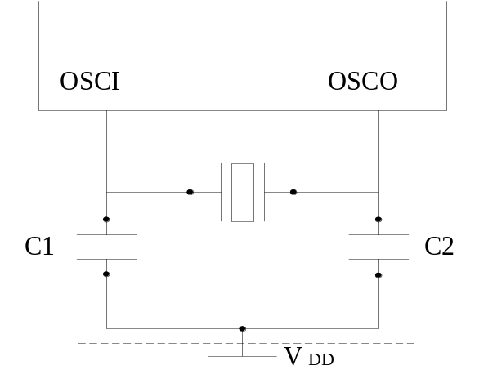

Caution If using an oscillation circuit, wire the area enclose in the dotted line in the figure in the manner indicated below in order to avoid negative effects such as from stray capacitance of wires.
• Keep wiring as short as possible.
• Do not cross other signal lines. Do not design wiring close to lines with large fluctuating current.
• Make sure that the connection point of the oscillation circuit's capacitor has the same potential as VDD.
• Do not extract signals from the oscillation circuit.

- PACKAGE DRAWINGS
- Package for the S0101
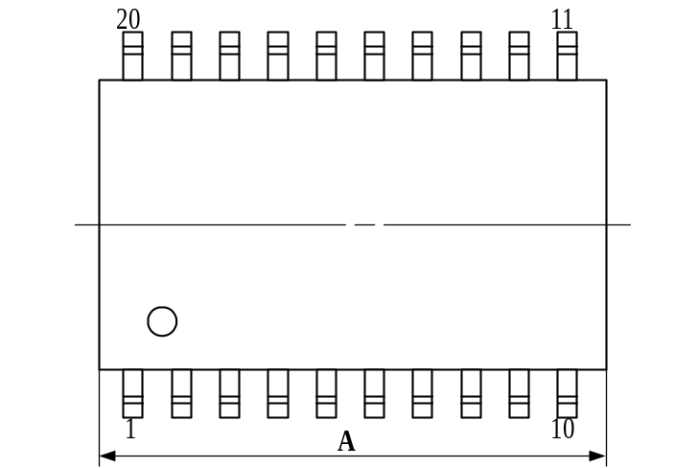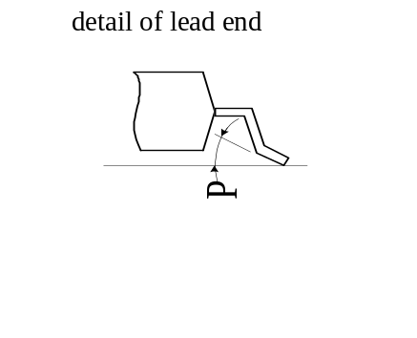20 PIN PLASTIC SOP (375mil)
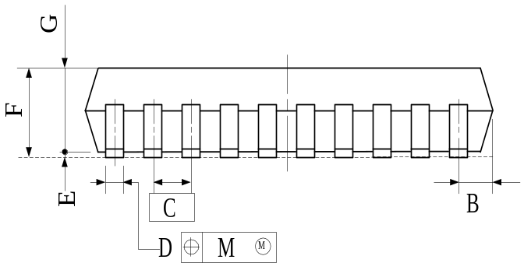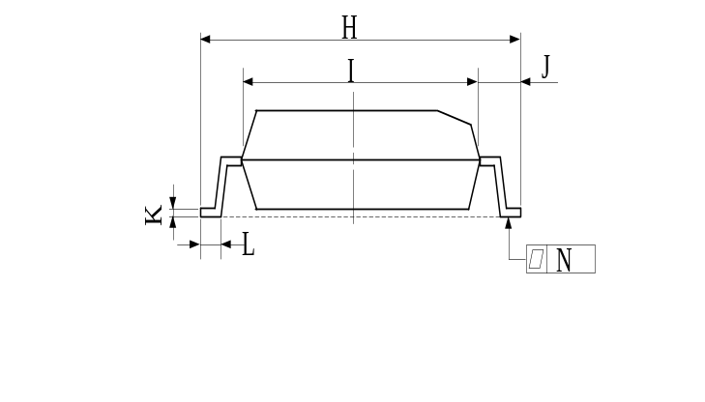
NOTE Each lead centerline is located within 0.12mm (0.005 inch) of
its true position (T.P.) at maximum material condition.

ITEM | MILLIMETERS |  |  | INCHES
A | 13.00 MAX. |  |  | 0.512 MAX.
B | 0.78 MAX. |  |  | 0.031 MAX.
C | 1.27 (T.P.) |  |  | 0.050 (T.P.)
D | 0.40 | ＋0.10  －0.05 |  | 0.016 | ＋0.004  －0.003
E | 0.125±0.125 |  |  | 0.005±0.003
F | 2.9 MAX. |  |  | 0.115 MAX.
G | 2.50 |  |  | 0.098
H | 10.3±0.3 |  |  | 0.406 | ＋0.012  －0.013
I | 7.2 |  |  | 0.283
J | 1.6 |  |  | 0.063
K | 0.15 |  | ＋0.10  －0.05 | 0.006 | ＋0.004  －0.002
L | 0.8±0.2 |  |  | 0.031 | ＋0.009  －0.008
M | 0.12 |  |  | 0.005
N | 0.15 |  |  | 0.006
P | 3° |  | ＋7°  －3° | 3° |  | ＋7°  －3°

- Package for the S0102
24 PIN PLASTIC SOP (375mil)
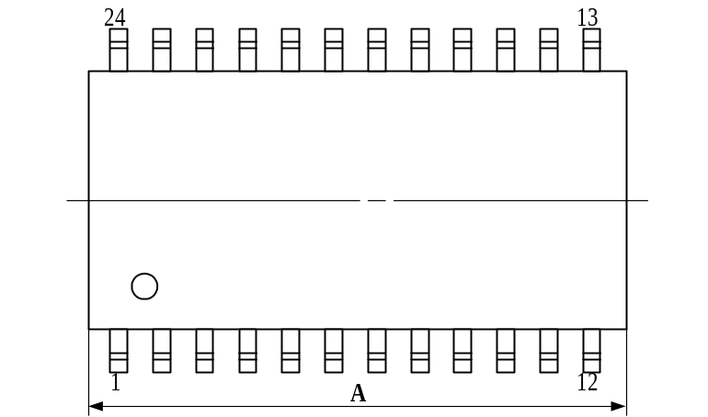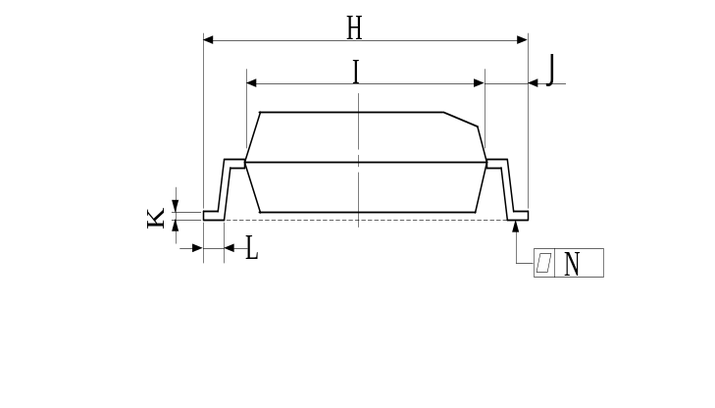

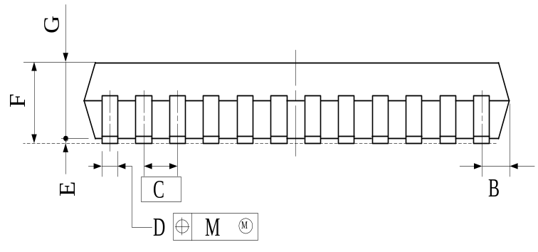NOTE Each lead centerline is located within 0.12mm (0.005 inch) of
its true position (T.P.) at maximum material condition.
ITEM | MILLIMETERS |  |  | INCHES
A | 15.54 MAX. |  |  | 0.612 MAX.
B | 0.78 MAX. |  |  | 0.031 MAX.
C | 1.27 (T.P.) |  |  | 0.050 (T.P.)
D | 0.40 | ＋0.10  －0.05 |  | 0.016 | ＋0.004  －0.003
E | 0.1±0.1 |  |  | 0.004±0.004
F | 2.9 MAX. |  |  | 0.115 MAX.
G | 2.50 |  |  | 0.098
H | 10.3±0.3 |  |  | 0.406 | ＋0.012  －0.013
I | 7.2 |  |  | 0.283
J | 1.6 |  |  | 0.063
K | 0.15 |  | ＋0.10  －0.05 | 0.006 |  | ＋0.004  －0.002
L | 0.8±0.2 |  |  | 0.031 |  | ＋0.009  －0.008
M | 0.12 |  |  | 0.005
N | 0.15 |  |  | 0.006
P | 3° |  | ＋7°  －3° | 3° |  |  | ＋7°  －3°

NOTES FOR CMOS DEVICES

① FRECAUTION AGAINST ESD FOR SEMICONDUCTORS

Note: Strong electric field, when exposed to a MOS device, can cause destruction of the gate oxide and ultimately degrade the device operation. Steps must be taken to stop generation of static electricity as much as possible, and quickly dissipate it once, when it has occurred. Environmental control must be adequate. When it is dry, humidifier should be used. It is recommended to avoid using insulators that easily build static electricity. Semiconductor devices must be stored and transported in an anti-static container, static shielding bag of conductive material. All test and measurement tools including work bench and floor should be grounded. The operator should be grounded using wrist strap. Semiconductor devices must not be touched with bare hands. Similar precautions need to be taken for PW boards with semiconductor devices on it.

② HANDLING OF UNUSED INPUT PINS FOR CMOS

Note: No connection for CMOS device inputs can be cause of malfunction. If no connection is provided to the input pins, it is possible that an internal input level may be generated due to noise, etc., hence causing malfunction. CMOS devices behave differently than Bipolar or NMOS devices. Input levels of CMOS devices must be fixed high or low by using a pull-up or pull-down circuitry. Each unused pin should be connected to VDD or GND with a resistor, if it is considered to have a possibility of being an output pin. All handing related to the unused pins must be judged device by device and related specifications governing the devices.

③ STATUS BEFORE INITIALIZATION OF MOS DEVICES

Note: Power-on does not necessarily define initial status of MOS device. Production process of MOS does not define the initial operation status of the device. Immediately after the power source is turned ON, the devices with reset function have not yet been initialized. Hence, power-on does not guarantee out-pin levels, I/O settings or contents of registers. Device is not initialized until the reset signal is received. Reset operation must be executed immediately after power-on for devices having reset function.

